The Research Study Allan Witherington

Creating an online community in a large secondary school

Context

The International School and Community College, East Birmingham is a large mixed 11-18 secondary school situated on a post-war housing estate on the eastern boundary of the city. There are approximately 1500 pupils, 100 teachers and 100 other staff. The school faces challenging circumstances (13% 5 or more A*-C at GCSE in 2002 with 46% of students taking free school meals). It was formed in September 2002 from two pre-existing schools on the same site with a new Senior Leadership Team. Responsibility for teaching and pupil progress lies with a leadership team of 3 within each of 5 year-based centres housed in separate buildings. (Fig.2)
Sheldon Centre
(Year 7)

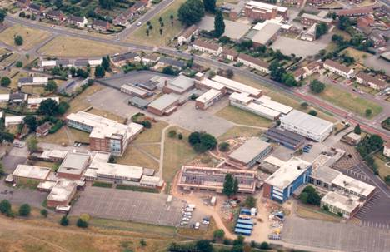
Martineau Centre
(Years 10 & 11)
Leycroft Centre
(Year 8)
Kenrick Centre
(Year 9)
Post-16 Centre
Fig. 2 Aerial view of school campus

As in many large schools, communication is an issue. Most staff work predominantly on one site and rarely meet as a whole staff or as subject groups. The use of e-mail is well established, but the school’s intranet is poorly developed. A survey of teacher opinion in October 2002 revealed dissatisfaction with the ‘sharing of information’ within the school. I considered that introducing an additional online communications platform could help the new school to develop as a cohesive community.

Research Aims

Three aims were identified at the outset:

- To analyse the processes involved in the creation and e-facilitation of an in-house on-line forum using bulletin board software.
- To investigate its effect on the level of participation in professional discussion, debate and learning of staff in a large school.
- To establish whether the discussion forums can became a useful and sustainable means of building a shared vision amongst staff and a ‘one school’ ethos.

The Process

Stage 1 Permissions

For such a project to be successful, it must have the wholehearted support of the school leadership. Fortunately, the Principal is committed to the concept of practitioner research and the school’s principles include, “We listen to each other and learn”, “We treat everyone openly and honestly” and “We involve our stakeholders”. Permission was granted and the Principal agreed to support the project by sitting in the ‘hot-seat’ in one of the forums.

Stage 2 Technical Issues

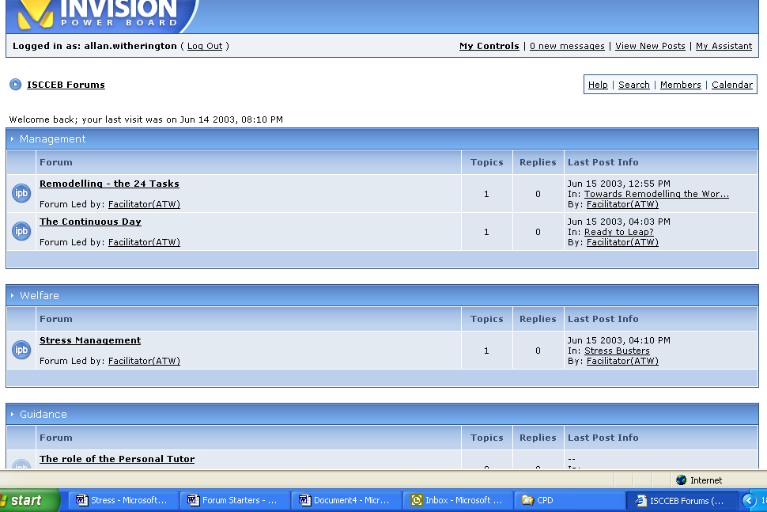
The software package used for the forums was the Invision Power Board (available free from www.invision.com - see Fig. 3). It proved straightforward to set up (about 2-3 hours) and most staff found it easy to use. It has a number of attractive features e.g. the use of emoticons and the facility to use avatars. I learnt of this package in the GTC e-facilitators’ forum and am grateful to fellow GTC scholar Neil McDonald for the tip. This was an example of ‘learning by lurking’ and illustrates the mutual support that an online community can provide.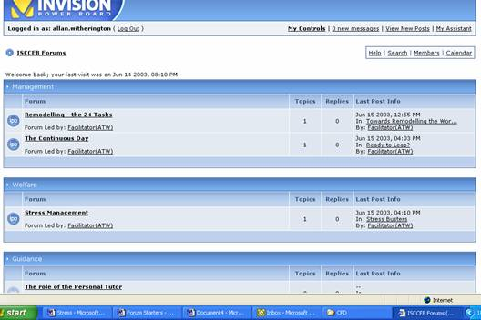
Fig. 3 Invision Power Board

Stage 3 Pilot Project

In order to test the system in use, a forum was established where the ICT Steering Group (8 people) could continue their discussions between their half-termly meetings. All 8 were experienced users of ICT, but they were also some of the busiest staff in the school. Disappointingly, only 5 members contributed a total of 8 postings, but the pilot did demonstrate that the system was sufficiently robust and flagged up the need to market this new facility very vigorously to the whole staff.

Stage 4 Registration and Regulation

It was decided to pre-register all teaching and support staff as members of the community in their full name e.g. Joe Soap. This decision caused confusion because some colleagues instinctively attempted to log on to the forums using the format, Joe.Soap which they use daily to enter the school’s network. This illustrates how carefully new ICT systems have to be designed to avoid frustration and loss of user confidence. Anonymous postings or the use of a false name was not possible. A Code of Conduct (Appendix 1) was established for the use of forums based on those used by the GTCE, the BBC and the TES sites. The following additional points were added to protect the institution and the staff who work in it.

- The discussions on the forums must be treated as confidential to members of the school staff.
- There is no hierarchy in this forum. All contributors are equally valued. Their contributions should not be taken to represent their ‘official’ positions as holders of particular responsibilities within the school.

Stage 5 The Launch

The name ‘The EAR’ was chosen to symbolise that views expressed in the forums will be listened to. For several weeks before the launch, teasing advertisements were placed in the weekly staff bulletin explaining that the EAR was on its way. On launch day, 15th May 2003, details of the first forums and clear instructions for logging on were e-mailed to all staff, together with a User Guide which included an explanation of the purpose of the EAR and my role as e-facilitator and moderator.

Stage 6 The Forums

Discussion topics chosen were topical and relevant to the national agenda or to changes taking place in the school. The number of contributors and number of postings attracted by each topic are shown in Fig 4.

Discussion Topic | No. of Contributors | No. of Postings | No. of Views
Stress Management | 5 | 6 | 42
Zone 6 (our complementary curriculum) planning | 10 | 35 | 233
Principles of Personal Tutoring | 7 | 9 | 73
The Principal in the Hot-seat on ‘Leadership’ | 9 | 13 | 115
The Continuous Day | 5 | 8 | 82
The remodelling agenda (the 24 tasks) | 5 | 6 | 62
ICT Steering Group Pilot | 6 | 8 | 68
Fig. 4 The Main Discussion Topics

Stage 7 Maintaining Interest

The following strategies were used in an attempt to maintain interest throughout the second half of the summer term.
- A new topic was introduced each week
- Regular advertisements were placed in the weekly staff bulletin
- Occasional e-mails were sent to all staff to encourage them to participate
- E-facilitation was welcoming and encouraging
- A financial inducement – a £10 weekly prize draw, one entry per posting
- The personal, face to face, encouragement of colleagues

Data Collection

The software provides useful statistical data about the frequency and timing of individuals’ participation. The content of the postings themselves can be used to give an insight into the motivation, interaction, and learning of members. Informal feedback was gained from conversations with colleagues and semi-formal interviews were conducted with 3 teaching and 2 support staff. However, the principal means of data collection was an anonymous questionnaire to all staff that was issued in the autumn term. The questionnaire (see Appendix 4) was designed to fit on 2 sides of A4, take no more than 5-10 minutes to complete and to elicit responses that were easy to record. A mixture of dichotomous questions, multiple-choice questions, Likert rating scales and open-ended questions was used. It was trialled with two colleagues before issue and 80 responses were received from a staff of 200.

The Main Findings and Discussion

Overall, participation in the project was lower than I had expected; 16% of teachers and 6% of support staff took an active part. 34 respondents to the questionnaire had attempted to access The EAR, 7 were unsuccessful and the commonest reason given was ‘couldn’t log on’. This is probably due to confusion over the format of the usernames referred to earlier. Preece (2000: 110) stresses the concept of usability and reminds us that:

“A well-designed interface is consistent, meaning that actions performed in the same way produce similar outcomes.”

The marketing strategy proved effective. Very few staff were unaware of the EAR and its purpose. However, only 15 staff could remember how to gain access. A link from the front page of the intranet has now been created to make access easier.

By far the most popular forum, with 35 postings, was the one concerning the planning of a new complementary curriculum for the school to be established in September 2003. Colleagues would have been engaged in this collaborative planning without the EAR, but its existence facilitated the dialogue. This demonstrates the widely recognised importance of establishing purpose and payback for participants in an online community. As Salmon (2002: 17) points out:

“It is a great mistake to assume that any participant will want to dedicate hours and hours to online conferences without good reason”

Excluding the e-facilitator’s contributions 104 postings were made over the six week period. A breakdown of the by gender and role is shown below.

 | Male | Female | Total
Teachers | 36 | 43 | 79
Support Staff | 20 | 5 | 25
Total | 56 | 48 | 104
Fig. 5 Number of Postings by gender and role

Males make up 45% of the teaching force and submitted almost exactly this proportion of the postings. There is no evidence here to support the widely reported finding that men tend to post more than women and tend to dominate online discussions (Cook et al. 2002). However, 80% of the non-teachers are female and they submitted only 20% of the postings. There are issues of lack of training and a degree of technophobia amongst some of the support staff.

Only 2 of 80 questionnaire respondents felt they lacked ready access to a computer at school, and 76% said they also had ready access at home. 69% accessed their e-mails several times a day, 26% once a day and only 5% less frequently than that. 20 staff had participated in discussion forums other than The Ear, 13 of them for purposes related to their work. The population as a whole is clearly computer literate.

The number of viewings exceeded the number of postings by a factor of approximately 10. There is little reliable published data on lurking levels but estimates of up to 100:1 are common. Lurking is a pejorative term suggesting free-loading but lurkers may well be silent participants who are learning from the expertise of others. 25% of respondents felt they had learnt by readings the views of others in The Ear. The most common reasons given by those who had lurked but never posted were that they had nothing to say or had too little time.

Only 4 respondents admitted being encouraged to participate by the £10 draw – but no-one turned the prize down! Surprisingly, only 5 of 29 responding participants said they felt inhibited by having to use their own name. And 9 out of 37 non-participants said they were more likely to have participated if they could have logged on anonymously or under a pseudonym.

The commonest reason given for non-participation was lack of time but a significant number found the medium too impersonal.

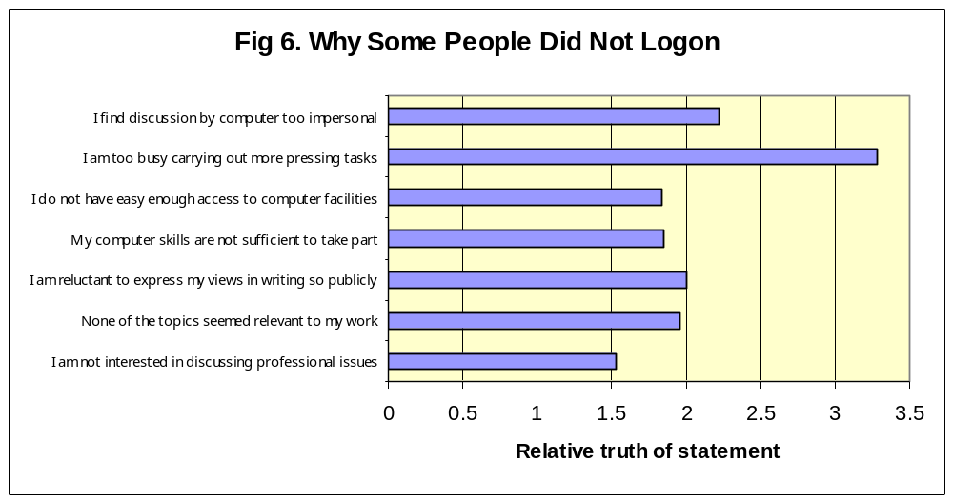

An analysis of 76 postings to the most popular forums was carried out using the Transcript Analysis Tool devised by Fahy (2003)(see Appendix 5). All but 2 contained comments identified as ‘supportive’. These comments were further grouped into 13 categories and the frequency of each is shown in Fig.7 Clearly we had established a forum where staff were interacting and encouraging each other’s involvement.

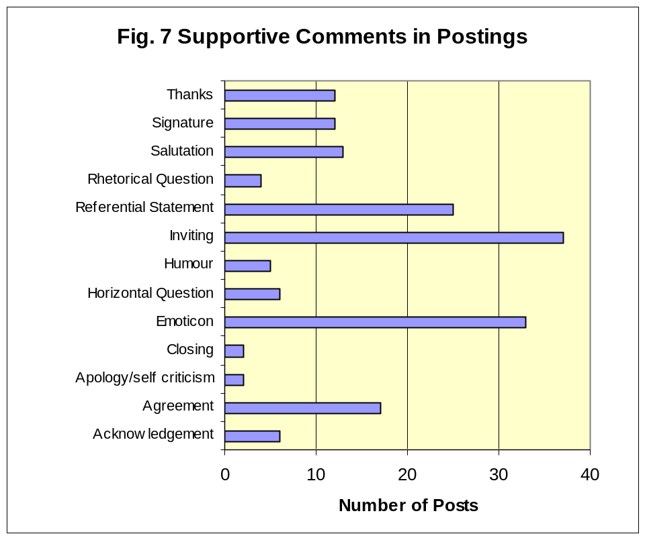

In a second classification, the supportive comments were ignored and postings were placed into one of the groups shown in Fig.8. I was encouraged by the high percentage of reflective comments that emerged.

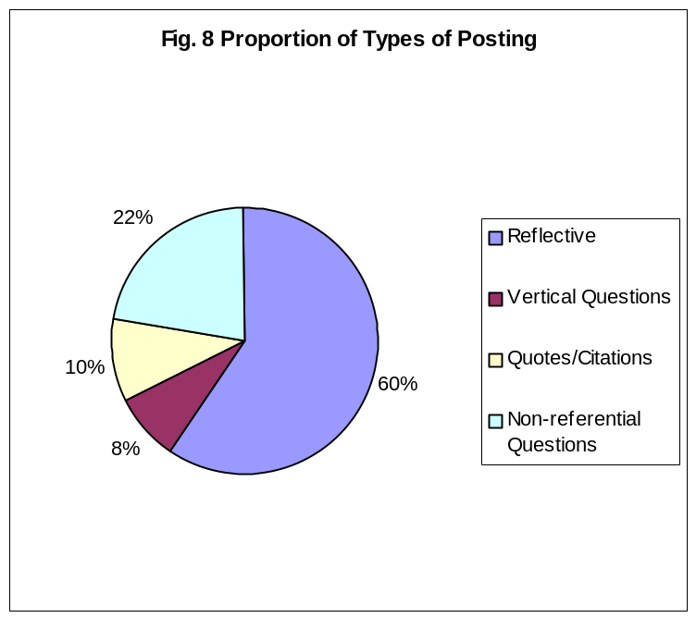

It must be stressed that this analysis, which was carried out by the researcher was difficult and very subjective. A repeat analysis, even by the same person, would be unlikely to yield exactly the same result.

An encouraging finding was the almost unanimous support for a continuing role for the EAR at the school. Fig.9 shows how respondents thought it could be useful.

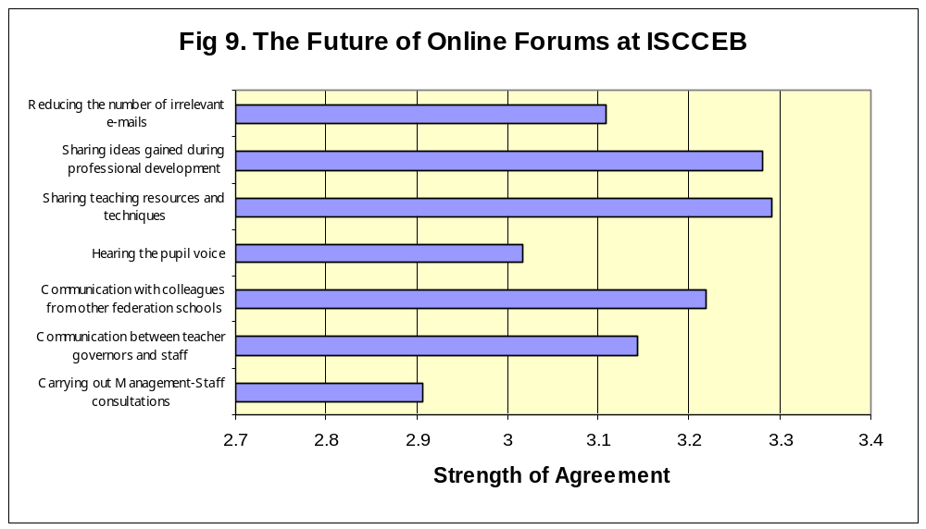
Conclusions

- A procedure for setting up a discussion forum for staff in a large school has been successfully established.
- Participants engaged in a positive discourse in a mutually supportive way and made reflective contributions. A quarter recognised they had learnt from the experience.
- Participation rate was low, lack of time being a more significant factor than lack of access or the fear of public ‘exposure’.
- The most successful forums were the hot-seat and those related to current tasks staff were engaged in.
- Almost all respondents feel there is a continuing role for the EAR
- The task of e-facilitation was quite straightforward. Many participants showed the skills needed for e-facilitation and could be trained to lead forums and make this development sustainable.

The aim to improve communication and create a one-school ethos was not achieved. Other factors caused turbulence and tension in the summer term. GCSE results plummeted to 9% 5 or more A*-C in 2003. In September the school formed a ‘hard federation’ with two successful Birmingham schools and in October the Principal resigned suddenly and was quickly replaced. The prospect of working as part of a federation opens up new opportunities for the school and increases the need for an online professional discussion forum. The EAR can play a significant part in the school’s revival.

